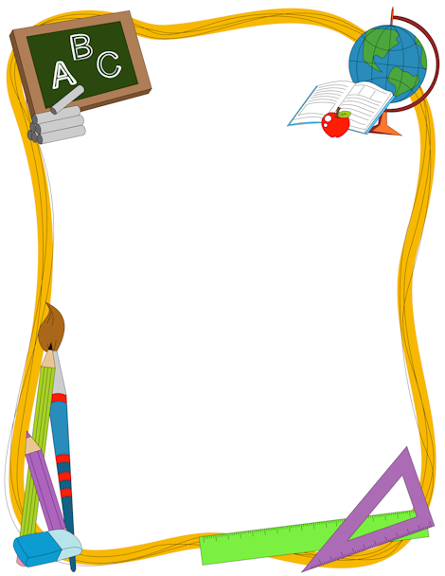

*2 BOXES OF 24 COUNT CRAYOLA CRAYONS*

*2 PACKAGES OF 24 COUNT #2 PENCILS*

*2-70 COUNT NOTEBOOKS (WIDE RULED)*

*1 COMPOSITION BOOK*

*3 PACKS OF WIDE-RULED NOTEBOOK PAPER*

*1 INCH BINDER*

*5 PLACTIC FOLDERS WITH POCKETS AND PRONGS*

*6 GLUE STICKS*

*2 BOXES OF KLEENEX*

*2 BOXES OF GALLON ZIP LOCK BAGS*

*1 BOX CRAYOLA MARKERS*

*1 BOTTLE OF HAND SANITIZER*

*1 PENCIL BOX*

*1 PAIR FISKAR SCISSORS*

*2 REAMS OF COPY PAPER*